Swinburne University of Technology

**Interface Design and Development**

Project Report for Trinacria Website

Marco Giacoppo (104071453)

Tuesday 10:30

2024 Semester

Table of Contents

Introduction 3

Website Functionality 3

Technical Overview 6

Frontend Technologies 6

Backend Technologies 6

Utilities and Tools 6

Innovative Features 7

Challenges and Solutions 7

Conclusion 8

# Introduction

The Trinacria website project was conceived to extend the reach of Trinacria’s culinary delights beyond its physical premises in Bali, allowing users worldwide to access its offerings. This digital initiative caters to the evolving needs of global diners who prefer convenient access to culinary experiences, reflecting a broader trend towards digital integration in the hospitality sector. The platform not only facilitates meal ordering and table reservations but also serves as a tool for enhancing customer loyalty and engagement through a seamless, interactive digital experience.

# Website Functionality

Trinacria is designed to cater to a variety of user needs, from browsing the menu to finalizing a purchase. The key functionalities include:

* **Menu Exploration**: Users can view detailed descriptions and images of each dish. The menu is categorized into sections such as pizzas, pastas, desserts, and drinks, allowing for easy navigation.

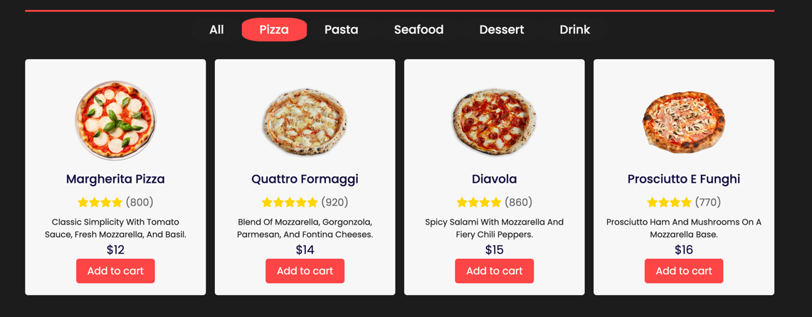

Figure 1: Menu Page showing different filters.

* **Account Management**: Customers can create personal accounts to manage their orders, view order history, and save preferences for future visits.

Figure 2: Register form with validations.

* **Dynamic Ordering System**: Incorporates features like adding items to a cart, modifying order quantities, and removing items as needed.

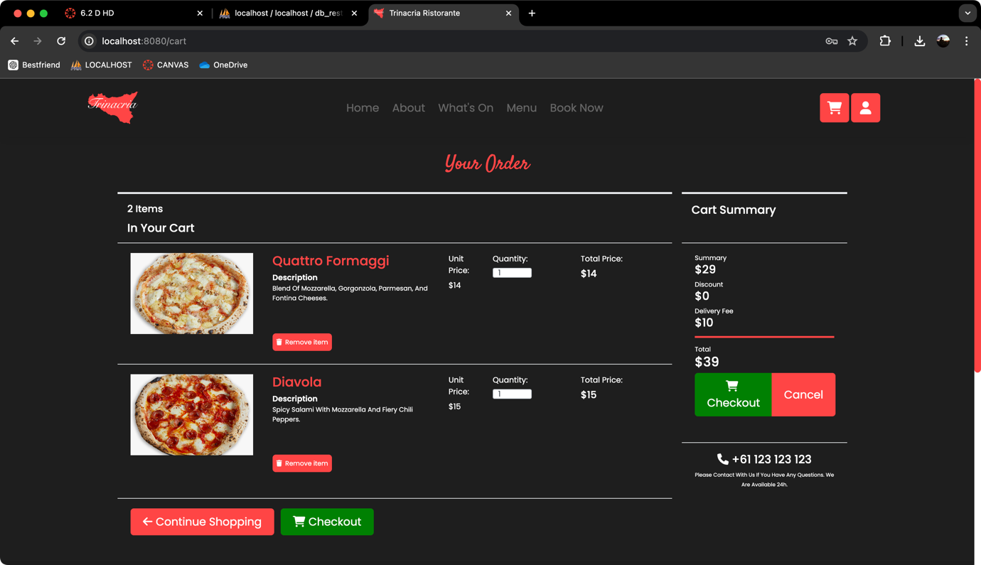

Figure 3: Shopping cart allowing users to modify their orders.

* **Reservation System**: Allows users to book tables in advance, with options to specify the date, time, and number of guests.

Figure 4: Book table form with validations.

* **Order Status Tracking**: Customers can track their order status from preparation to delivery through their user dashboard.

Figure 5: Order info to let users know their order updates.

* **Interactive User Interface**: The website features responsive design elements that adjust to different device screens, ensuring a smooth user experience across all platforms.

Figure 6: Responsive design on other devices.

# Technical Overview

The Trinacria website is built using Vue.js and Bootstrap, ensuring a responsive and modular design. Key aspects of the technical implementation include:

## Frontend Technologies

Vue.js forms the cornerstone of our frontend architecture. It provides a progressive framework for building user interfaces, enabling dynamic and single-page applications that enhance user experience.

The use of Vue.js is complemented by Bootstrap and Tailwind CSS, which furnish the application with responsive and modern design patterns. These CSS frameworks ensure that the application is accessible and visually appealing across all devices and platforms.

Additionally, Google Fonts and Font Awesome are integrated to enrich the UI with versatile typography and scalable icons, thereby improving the aesthetic appeal and user navigation experience.

## Backend Technologies

The server-side operations are powered by Node.js, with Express.js serving as the web application framework. This setup facilitates efficient routing and API management, essential for handling the application's data processing needs.

Apache HTTP Server is employed, for serving static files or managing reverse proxy configurations, which adds a layer of flexibility in handling web server requests.

## Utilities and Tools

For client-side HTTP requests, Axios is utilized, enabling seamless API interactions and state management in conjunction with Vuex. The integration of jQuery, although minimal, supports certain dynamic elements within the application.

# Innovative Features

The website integrates several features designed to enhance user interaction and streamline operational efficiency. Key innovations include:

1. **Real-Time Data Interaction:**

Leveraging Vue.js's reactivity, the website updates real-time data such as cart totals and order updates without the need for a page refresh. This dynamic update system ensures that users always have the most current information at their fingertips, enhancing the shopping experience and minimizing errors during order placement.

1. **Responsive Web Design:**

The site is fully optimized for all devices, utilizing Bootstrap's grid system to dynamically adjust the layout according to the screen size and resolution. This ensures a consistent and accessible user experience whether on a desktop, tablet, or smartphone.

1. **Integrated Payment Solutions:**

The platform right now only supports various payment methods, including credit cards and cash. This integration facilitates a seamless checkout process. We will add some other payment methods in the future (Cryptocurrency, digital wallets, etc.)

# Challenges and Solutions

Throughout the development of the Trinacria website, several challenges were encountered and overcome:

* *User Experience Optimization*: Balancing the rich media content with performance. Solution involved lazy loading images and prioritizing content delivery.
* *Database Integration*: Ensuring real-time sync across various components was challenging due to the asynchronous nature of JavaScript. This was addressed using Vue.js’s reactive properties and efficient state management with Vuex.
* *Security Concerns*: Protecting user data and transactions. Implemented stringent security protocols, regular audits, and encrypted data channels.

# Conclusion

Creating this website has been a significant step towards realizing my dream of opening my own restaurant in the future. Throughout this project, I've had the opportunity to delve into a new programming language and grasp various aspects of web development, from routing to integrating backend servers into a cohesive project. It has been an incredibly enriching experience, teaching me valuable skills along the way.

This journey has been more than just about building a website; it's been about laying the foundation for my entrepreneurial aspirations. Each assignment has been a learning opportunity, equipping me with the knowledge and confidence to pursue my goals.

As I reflect on this process, I'm struck by how accessible and user-friendly the tools and technologies have been. They've not only simplified the development process but also empowered me to bring my vision to life.